Project Title (12 words maximum)
Responsible Artificial Intelligence for a Smart Economy (RAISE): Leading Trustworthy Innovation Globally

Public Statement (200 words maximum)
Responsible Artificial Intelligence for a Smart Economy (RAISE) will position New Zealand at the forefront of shaping trustworthy and safe AI for everyone. This initiative takes an interdisciplinary approach to bring together top academics, industry experts, and Māori innovation networks in developing new AI technologies that are transparent, explainable, and operate in ways people can understand. RAISE is guided by New Zealand’s reputation for integrity, upholding human rights, and demonstrating transparency, with a vision to ensure AI is built and used with our highest values in mind.

RAISE’s research will develop real-world AI tools that help organisations deliver smart and safe solutions, positioning New Zealand as a global leader in trustworthy innovation. Impact ranges from expert technical research to the development of AI guidelines and regulatory frameworks that provide appropriate safeguards for the productive innovation and adoption of AI. There is global demand for safe and trustworthy AI; RAISE will deliver this research and translate it into commercial outputs. By developing the next generation of AI talent, enhancing public science communication, and building industry and international partnerships, RAISE will ensure that AI grows New Zealand’s high-tech economy while protecting our communities.

Contact: Dr Andrew Lensen (andrew.lensen@vuw.ac.nz)

Executive Summary (250 words maximum)
Responsible Artificial Intelligence for a Smart Economy (RAISE) will position New Zealand as a global leader in responsible AI, building on our trusted reputation for integrity, human rights, and transparency. Our vision delivers world-class research and solutions with enduring benefits for Aotearoa’s economy and society, grounded in integrity, equity, and Kiwi values.

RAISE will create value across three pillars:
1. Conducting research to develop trustworthy technology, supporting organisations to deploy AI responsibly.
2. Shaping fit-for-purpose AI governance and regulatory frameworks aligning with international best practices.
3. Building responsible AI systems with industry and the public sector in high-value, high-impact areas.

Appropriate use of AI offers significant economic and other benefits. However, AI innovation and adoption are hampered by a lack of trust. Multiple recent surveys have shown over half of New Zealanders are very concerned about the negative impacts of AI. Building trust demands more than technical sophistication: it requires a holistic approach, embedding transparency and explainability, underpinned by regulatory and governance structures that unleash responsible innovation.

The global market for responsible and explainable AI is expanding rapidly. Recent estimates project the explainable AI market alone will exceed US$20 billion by 2030, reflecting demand in sectors such as healthcare, finance, and government.

Investment into RAISE will create new collaborations, attract top talent, and deliver research and capability that existing initiatives alone cannot. RAISE will position New Zealand as a global influencer in AI policy and practice, through our interdisciplinary approach spanning academia, industry, government, and Māori innovation networks.

Concept Outline (1500 words maximum)

Our Vision
AI could add $76b to New Zealand’s GDP by 2038, powering our future high-tech economy. However, research has shown that these productivity gains are undermined by unreliable outputs, biased decisions, and safety concerns. To realise these economic benefits, we need trustworthy AI, giving consumers and businesses the confidence to engage.

Our vision is to establish NZ as a global leader in responsible AI (RAI) innovation and deployment, where safety, integrity, and reliability drive our competitive edge. This proposal directly addresses NZ's low public trust in AI, recasting it as a market asset and a cultural strength with export appeal. Responsible, NZ-designed AI will be synonymous with verifiable safety and ethical value, creating a sought-after model for trustworthy technology worldwide. Research shows that the biggest gains are realised by companies that invest in adopting AI responsibly, with RAI generating a financial premium.

By focusing on trustworthy AI, the Responsible Artificial Intelligence for a Smart Economy (RAISE) platform will enable innovation and counter the primary barriers to adoption: regulatory uncertainty, and perceived ethics and risk. Appropriate regulation can promote, rather than inhibit, innovation by providing certainty on boundaries, spurring the development of solutions with confidence. Trust, along with Motivation, Access, and Skills (MAST), is key to realising The Digital Strategy for Aotearoa, necessary for enabling public adoption. A focus on “trust by design” will be a key competitive advantage, enabling our exports to thrive in international markets with complex regulatory environments. This will attract international investment, open new markets, and support the government's strategic focus on being a "smart adopter" of AI.

RAISE will serve as the national "centre of gravity" for AI research, policy, and commercialisation. It will formalise and empower national and international experts to work with industry and government, translating international principles (like those from the OECD and UNESCO) into practical, innovation-friendly frameworks. It will foster world-class research to develop practical tools for AI governance, and serve as a trusted advisor and public voice, building the capability required for wide-scale, beneficial AI adoption. RAISE will develop internal commercialisation capability to move successful research into real-world products and services. The team has a diverse range of existing RAI projects that will be combined and rapidly scaled up for fast impact and a rapid return on investment.

The key goal of RAISE’s research will be to develop locally-appropriate and world-leading solutions to achieve end-to-end responsibility, encompassing both transparency (of systems) and accountability (of humans and organisations). This work is inherently interdisciplinary, and must be delivered locally for it to be useful in NZ, considering the local economic, industrial, and cultural contexts.

Excellence
RAISE’s research will be built on three pillars:
- Trustworthy Technology: developing technical advancements in transparency, robustness, explainability, security, and safety.
- Trustworthy Frameworks: establishing thought leadership in accountability, ethics, human rights, governance, and regulation.
- Trustworthy Systems: building infrastructure and solutions collaboratively with industry and the public sector to demonstrate the efficacy and value of responsible AI systems, through initiatives like the applied doctorates scheme, subsidised consulting for SMEs, and incubating ideas into spin-out companies.

These pillars are designed so that the application-driven research in the Technology and Frameworks pillars (TRL 2-4) can be put into practice through the Systems pillar (TRL 5-7). Illustrative examples of potential projects that build on the team’s expertise include:
- Developing novel methods for explainable and verifiable AI to achieve transparency in medical AI diagnostic tools and decision support systems to enhance patient trust
- Building a sovereign large language model (LLM) with Catalyst Cloud, Public AI Network, and Metagov, supporting responsible use of genAI in NZ
- Partnering Vision Mātauranga in an AI context to develop tools grounded in te ao Māori and create high-value Indigenous economic opportunities
- Testing privacy-preserving environmental monitoring to balance transparency with personal and community privacy rights
- Building targeted genAI models for specific legal and commercial applications to mitigate the likelihood of hallucination
- Embedding complex ethical and legal norms into agentic AI and other automated systems for delivering public services

This consortium brings together NZ’s leading minds across disciplines essential for an RAI ecosystem: computer science, engineering, law, ethics, human rights, Mātauranga Māori, and the social and cognitive sciences. Investment into RAISE will bridge disciplinary boundaries and cohere this world-class capability into a strategic national asset, delivering the "additionality" sought by the Call.
The founding team includes a mixture of senior, mid-career, and early-career academics from six NZ universities, alongside industry partners. It includes extensive experience in science leadership, including Heads of School/Department, and Principal Investigators who have collectively managed $10m+ in research grants. Several members have private sector experience, including in the commercialisation of deep tech start-ups and in leadership positions.

Trustworthy Technology: Dr Andrew Lensen (proposal lead), Prof Michael Winikoff, Prof Stephen Cranefield, Prof Brendan McCane, Prof Grant Dick, A/Prof Hui Ma, Dr Emily O’Riordan, Dr Veronica Liesaputra, Dr Caitlin Owen
Trustworthy Frameworks: Prof Alexandra Andhov, Prof Nick Agar, Prof Ali Knott, A/Prof Stephen Hill, Dr Cassandra Mudgway, Dr Michael Daubs, Dr Olivia J Erdelyi, Dr Ethan Plaut, Dr Andrew Richmond
Trustworthy Systems and Industry Expertise: Dr Andrew Chen, Chris McGavin, Paul Seiler (Catalyst Cloud), Deane Sloan (Equinox IT), Dave Moskovitz, Prof David Eyers, Dr Heitor Gomes
Indigenous Māori AI Experts: Prof Hemi Whaanga, Dr Kirita-Rose Escott, Dr Jesse Pirini (Executive Chair of Te Matarau a Māui); Dr Kevin Shedlock, and the wider Hiringa te Mahara team

RAISE will track outcomes in scientific excellence (e.g. publications and citations), commercialisation (e.g. start-ups created, capital raised), and societal impact (e.g. public engagements, changes in public perceptions).

RAISE will be governed by a Board comprising a mix of academic, Māori, and industry members, providing accountability and oversight. We also plan to establish a Research Board with international and Vision Mātauranga expertise to provide strategic direction for RAISE, and a Community Advisory Board to inform the research work through engagement with relevant community groups. RAISE’s operational team will include Māori co-leadership.

Connections
Our team has a strong track record of collaboration in both domestic and international AI research and industry networks, particularly in the areas of AI trust and safety. We will leverage our positions in high-level international forums, including the OECD, the EU’s AI office, and the Global Partnership on AI (GPAI), as well as relationships with prominent global researchers such as Prof Yoshua Bengio (University of Montréal), Prof Shannon Vallor (BRAID), Prof Stuart Russell (UC Berkeley), and Prof Virginia Dignum (Umeå AI Policy Lab). This will create a pipeline of global talent through visiting fellowships and funded positions, establishing RAISE as an enduring and world-class multidisciplinary RAI research community.
Formal partnerships with the global network of AI Safety Institutes will further expand our international reach. NZ's scale and social cohesion make it the ideal place to study the real-world societal impacts of AI deployment. RAISE's value proposition will be to serve as a world-leading centre for sociotechnical evaluation, directly addressing the investment goal to "foster and grow international research and development", and creating a high-value role for NZ in the global ecosystem.

Vision Mātauranga is woven into RAISE in partnership with the Hiringa Te Mahara Māori research team, whose expert collaboration spans global indigenous communities, and Te Mataurau a Māui, a network of Māori businesses keen to test and trial AI. These networks will help RAISE connect with iwi/hapū authorities, tribal NGOs, and Māori academics across Aotearoa. For Māori, responsible AI is critically important to the sustainable development of the Māori economy, with wide-ranging benefits for the whole of NZ.

RAISE will build on existing relationships domestically with key industry bodies (e.g. AI Forum), research communities, and the innovation and investment ecosystem to ensure research is commercially relevant and rapidly implemented. RAISE will play a vital role in catalysing industry as a centralised hub for organisations to easily access NZ’s leading interdisciplinary AI experts.

Investing in People
RAISE will help cultivate the next generation of AI talent, ensuring they are both technically brilliant and socially and ethically literate. They will be equipped with foundational, multidisciplinary skills that will be highly sought after as markets and technology continue to evolve, directly supporting the government’s goal of building a “future-ready workforce”. There will be a focus on training master’s and doctoral students, including through the applied doctorates scheme, to develop industry-ready expertise in RAI. Many members of this proposal are experienced supervisors of interdisciplinary thesis students.

RAISE will also develop new interdisciplinary postgraduate coursework curricula. It will seek early engagement with strategic partners, such as REANNZ, PROs, and industry partners, to ensure the curriculum meets the needs of the emerging AI workforce and secures preemptive buy-in. This will create a pipeline of graduates with the unique, multidisciplinary skills required for the RAI economy. RAISE will also actively inform and educate the New Zealand public about the safe use of AI, thereby addressing the knowledge and skills barriers that impede AI uptake, while building public trust that enables businesses to deploy RAI confidently.

This proposal was edited using Gemini and Perplexity genAI tools.
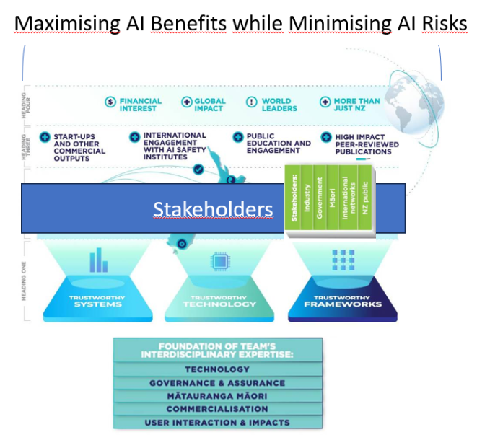
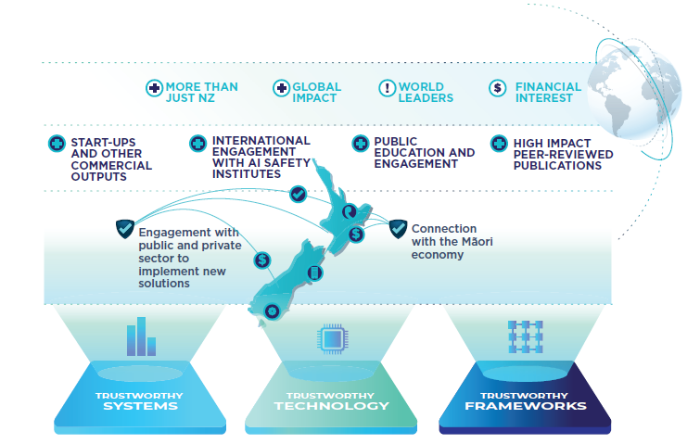

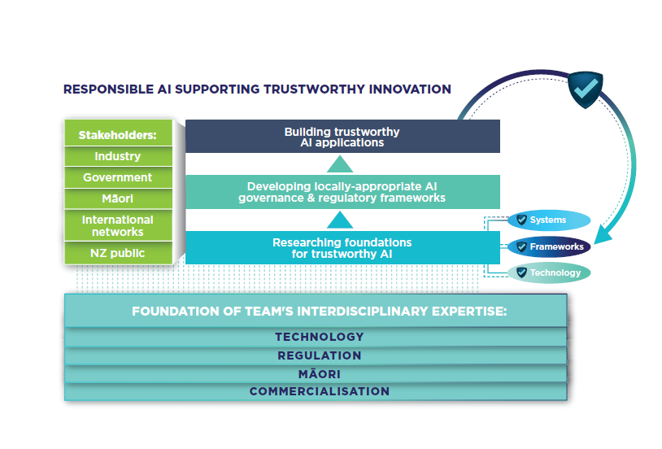
I've tried to create a figure that captures the key ideas of the proposal - image below, PowerPoint here. Obviously I'm not a designer - feel free to adapt or ignore.
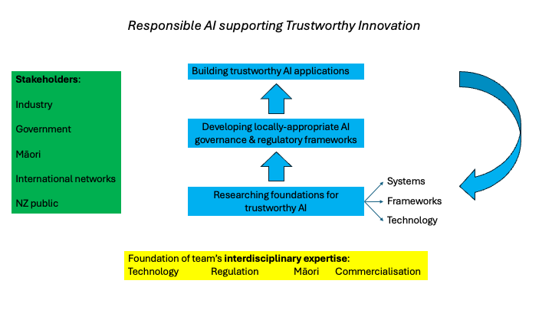
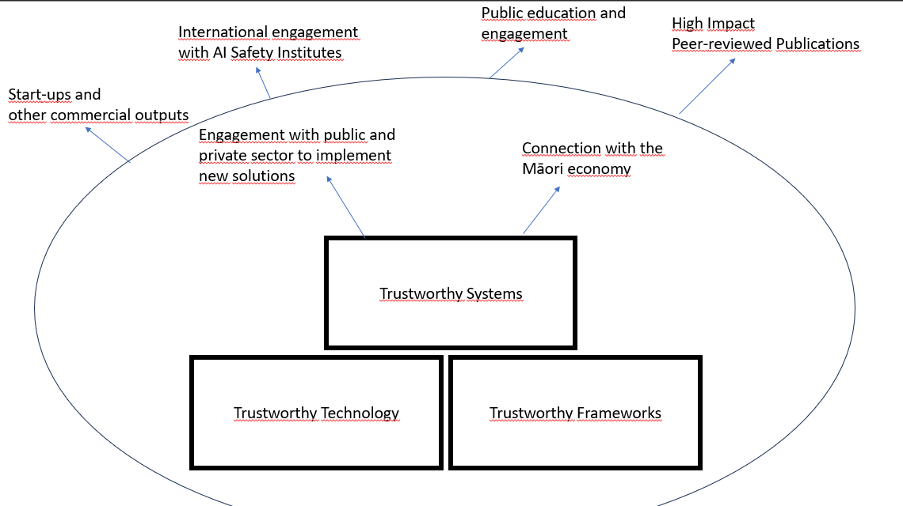

Building Responsible AI in New Zealand (BRAINZ): International Leader in Trustworthy Innovation

Phase 1 assessment criteria

Excellence
Weighting: 35%
Applicants should:
- demonstrate emerging or existing world-class science and research capability in AI
- demonstrate the skills and knowledge the team possesses, particularly leadership expertise and experience
- provide ambitious thinking on novel approaches for future AI research and areas to address.

Vision
Weighting: 35%
Applicants should:
- set out a vision for how their science and research capability in AI can be applied to provide New Zealand with an enduring competitive advantage and can generate high-tech, knowledge-intensive firms that grow and diversify New Zealand’s future economy
- describe why this vision makes sense as a New Zealand research investment, i.e. “why would this be done in New Zealand?”
- describe their early thinking on managing and driving the science and research to deliver outcomes
- set out a vision for creating an AI institute that can be a focal point for domestic and international engagement on AI and a centre of gravity for building capability and strengthening research-industry engagement.

Connections
Weighting: 20%
Applicants should:
- elaborate their existing AI research and industry connections and collaborations (both New Zealand and internationally), and how these will be developed and expanded, to help realise the vision.

Investing in people
Weighting: 10%
Applicants should:
- demonstrate a track record of developing advanced AI research capability.
Note: For research entities, this might be demonstrated by training of post-graduate research students. For industry entities, this might be demonstrated by structured staff training, support for graduate placements, etc.
(See call for proposal doc — it has what is required for each of these four headings. We do have to use ‘em…) Call for proposals for the Artificial Intelligence Research Platform

Public Statement
Your public statement will not be assessed but if your proposal is successful, it will be published on MBIE’s website with the name of the contracting organisation and Principal Investigator(s).

The audience for your public statement is the general public, so it needs to be written in a way that is engaging, easy to understand, and shows a good use of taxpayer money. It’s important that your public statement accurately captures the underpinning science and clearly describes the outputs from the project in a way that is understandable by a wider audience.

If available, provide publishable contact details that can be used by members of the public and/or the media.

Do not include confidential information, references, hyperlinks, images, video or audio files.
Enter your answer here…

Note: no hyperlinks in the public statement!

Executive Summary
Summarise your vision for a successful Artificial Intelligence Research Platform. Tell a compelling story about the research and science underpinning your vision and the impact it could have. Explain how your Platform will create additionality which would not happen without this investment. Include ambitious thinking, new people, new collaborations, new and expanded research, and new impacts. Your executive summary should consider the assessment criteria and refer to the investment goals.

